PARASITE

THREE ONE-ACT PLAY

TABLE OF CONTENTS

CONTROL (A SKETCH FOR A PORTRAIT OF THE DOMINANT) 1

VULNERABILITY (A SKETCH FOR A PORTRAIT OF THE EXPOSED) 2

DEPENDENCE (A SKETCH FOR A PORTRAIT OF THE DEPENDENT) 3

CONTROL
(A sketch for a portrait of the dominant)

CHARACTERS

AN EAGLE HUNTER, late 50s, weathered, reticent, with a slight tendency for melancholia

SETTING

Snow covered Kazakh steppes. There is nothing here: the milky skies have gobbled up the pale earth.

He follows you wherever you go. He shares your fear, your exultation, your boredom. As in some primitive ritual, he mimics your movements, your moods. The predictability of his pace makes your more trusting, more curious. He even leant to fear. To share fear is the greatest bond of all. By ‘fear’ he does not mean fear of the unknown, the intangible, the suffocating abstract of the mind. What he means is a reel, physical, cold sweating, shivers running down spine kind of fear.

VULNERABILITY
(A sketch for a portrait of the exposed)

CHARACTERS

EAGLE IN ITS PRIME, restless, bold

SETTING

31,000 feet above what looks like a computer generated landscape. At this attitude: there’s no sense of smell, no taste, no resistance, no foreign bugs, no audience, no one to be held accountable.

wOOOOOOOOOHOOOOOOOOOOOOOO –

What a soar
What a dash
What a rush
What a leap
into light into dark
What a time
What I left

Then.

Gone.

Wooo

ooo

oo

o

DEPENDENCE
(A sketch for a portrait of the dependent)

CHARACTERS

A JANITOR, late 40s, plainly dressed, shy, with a stutter.

SETTING

A small office with the deskin the middle. On the desk: emptied out trash, property of C. B. P. (Customs and Border Protection Agency): all of the trash items are neatly arranged according to naturally occurring and repeating categories, ready to be covertly photographed. On the wall above, a sign that says “PERSONAL ITEMS CONFISCATED DURING MIGRANT INTAKE ARE CONSIDERED NON-ESSENTIAL PROPERTY AND MUST BE DISCARDED”.

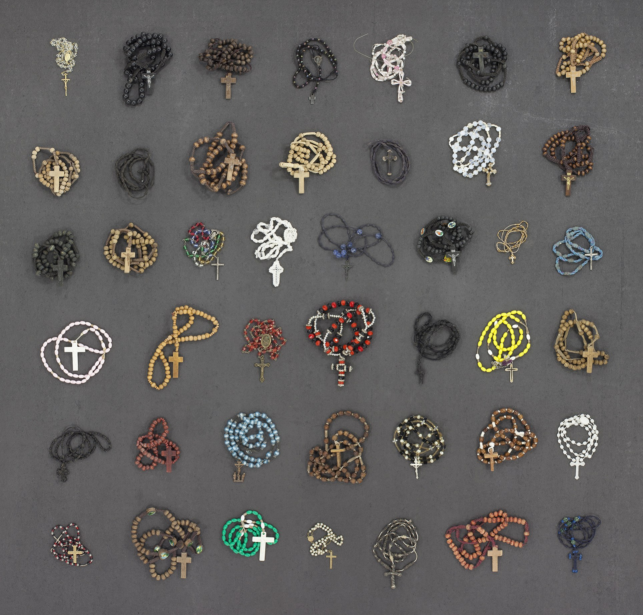
THOMAS KIEFER / INSTITUTE

© Alyona Larionova 2018

